UNCLASSIFIED

UIAO Documentation Pipeline
Setup & Configuration Guide
Author: UIAO Program Office
Date: April 2026
Version: 1.0.0
Classification: UNCLASSIFIED

Table of Contents
• 1. Executive Summary
• 2. Repository Structure
• 3. Quarto Project Configuration (_quarto.yml) 3.1 Project Settings 3.2 Website Navigation 3.3 HTML Format 3.4 DOCX Format 3.5 PPTX Format 3.6 Execution & Freeze 3.7 Diagram Rendering 3.8 Cross-References 3.9 Profiles
• 4. Production Profile (_quarto-production.yml)
• 5. GitHub Actions Workflows 5.1 Main Pipeline: build-and-publish.yml 5.2 PR Gate: pr-check.yml
• 6. Lua Provenance Filter (_filters/uiao-metadata.lua)
• 7. Post-Render Hook (scripts/post-render.sh)
• 8. Custom Theme (assets/css/uiao-theme.css)
• 9. Developer CLI (scripts/local-dev.sh)
• 10. Diagram Rendering Guide 10.1 Mermaid Diagrams 10.2 GraphViz Diagrams
• 11. Reference Template Setup
• 12. Output Formats Summary
• 13. Integration Instructions 13.1 New / Empty Repository 13.2 Existing Repository with Content 13.3 GitHub Pages Activation
• 14. Adding New Documents
• Appendix A: Complete File Listing
• Appendix B: Environment Variables

1. Executive Summary

This guide documents the end-to-end documentation pipeline for the Unified Integration Architecture & Operations (UIAO) program. The pipeline is built on Quarto and renders .qmd source files to three output formats:
- HTML — published to GitHub Pages
- DOCX — governance deliverables
- PPTX — briefing decks
The pipeline includes native Mermaid and GraphViz diagram rendering, a Lua-based provenance filter that injects build metadata into every output, and two GitHub Actions workflows for automated builds, validation, and deployment.

Design Principle
The pipeline is designed for zero-drift, provenance-first governance — every output traces back to a source commit. No manual rendering steps are required. All outputs are deterministic and reproducible.

2. Repository Structure

The pipeline is organized within a single repository. The directory tree below shows every file and its purpose:
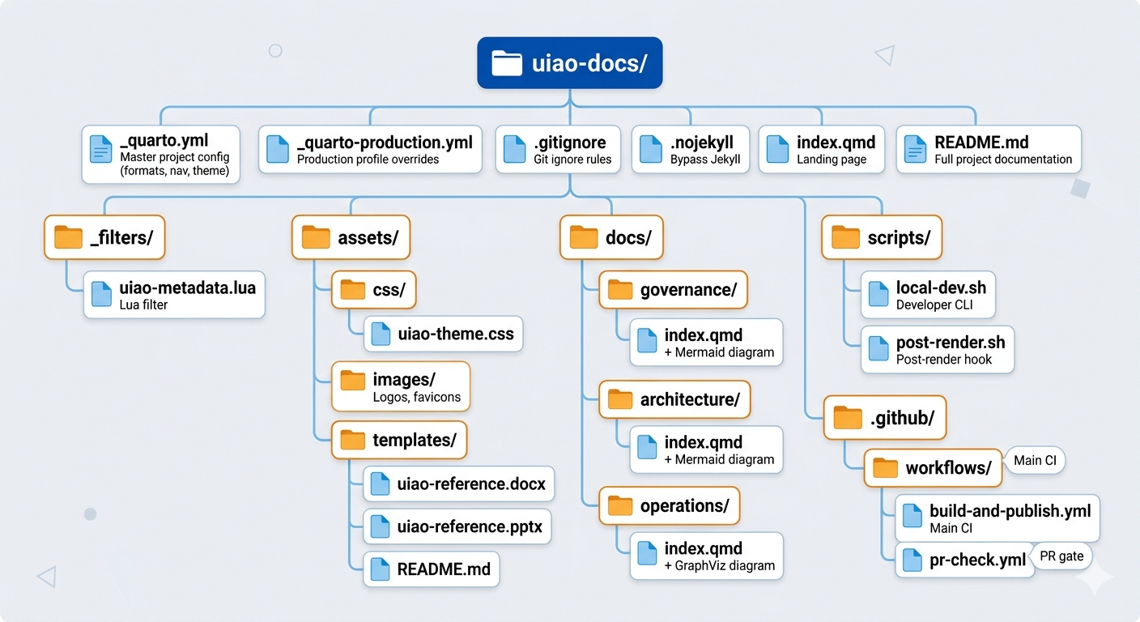

Each file has a specific role in the pipeline. The following sections detail every configuration file, filter, script, and workflow in full.

3. Quarto Project Configuration (_quarto.yml)

The _quarto.yml file is the single source of truth for the entire rendering pipeline. It defines the project type, output formats, navigation structure, theme, execution behavior, and diagram rendering options. Every rendering decision flows from this file.

3.1 Project Settings

Setting | Value | Description
type | website | Enables website navigation, sidebar, and search features
output-dir | _site | All rendered HTML output is placed in this directory
render | *.qmd, docs/**/*.qmd | Renders all .qmd files under root and docs/
Excluded paths | _templates/, _scratch/ | Directories excluded from rendering
post-render | scripts/post-render.sh | Hook script executed after every render cycle

3.2 Website Navigation
The website navigation is configured with the following components:
- Navbar: Top-level navigation bar with links to Governance, Architecture, and Operations menus
- Sidebars: Floating sidebars for each section, providing page-level navigation within a content area
- Search: Full-text search overlay, enabling users to find content across the entire site
- Repository links: GitHub repo link with Edit this page and Report an issue actions
- Footer: Page footer with copyright and build metadata

3.3 HTML Format

Setting | Value
Base theme | Cosmo (Bootswatch) with custom CSS overlay (assets/css/uiao-theme.css)
Table of contents | Depth 3, expandable to level 2
Section numbering | Enabled
Code copy button | Enabled
Anchor sections | Enabled
Smooth scroll | Enabled
Grid layout | 280px sidebar · 900px body · 280px margin

3.4 DOCX Format
- Reference document: assets/templates/uiao-reference.docx
- Table of contents: Depth 3
- Numbered sections: Enabled
- Highlight style: GitHub

3.5 PPTX Format
- Reference document: assets/templates/uiao-reference.pptx
- Slide level: 2 (H2 headings create new slides)

3.6 Execution & Freeze

Context | Freeze Setting | Behavior
Local development (default) | freeze: auto | Computations are cached and re-run only when source files change
Production / CI | freeze: true | Never re-execute computations; use only cached results

Additional execution settings applied in both profiles:
- echo: false — Do not include source code in output
- warning: false — Suppress warning messages
- message: false — Suppress informational messages

3.7 Diagram Rendering
Quarto natively renders {mermaid} and {dot} code blocks — no plugins or extensions are required.

Aspect | Detail
Mermaid theme | neutral
HTML output | Diagrams render as interactive SVGs
DOCX / PPTX output | Quarto uses Chrome Headless Shell to convert diagrams to high-quality PNGs

3.8 Cross-References
Cross-reference prefixes are configured for consistent labeling across all output formats:

Type | Prefix
Figure | fig-
Table | tbl-
Equation | eq-
Section | sec-

3.9 Profiles

Profile | Activation | Behavior
Development (default) | No environment variable needed | freeze: auto, normal rendering
Production | QUARTO_PROFILE=production | freeze: true, minified HTML output

Profiles are activated by setting the QUARTO_PROFILE environment variable. The CI workflow sets this automatically.

4. Production Profile (_quarto-production.yml)

The _quarto-production.yml file is a companion override file activated by setting QUARTO_PROFILE=production. It hardens the build for CI/CD environments by applying the following overrides:
- Freeze: Forced to true — computations are never re-executed in CI. This guarantees that CI builds use only pre-cached results, preventing non-deterministic outputs.
- HTML minification: Enabled — reduces HTML file sizes for faster page loads on GitHub Pages.

Note
The CI workflow (build-and-publish.yml) sets QUARTO_PROFILE=production automatically. You do not need to configure this manually unless running production builds locally.

5. GitHub Actions Workflows

5.1 Main Pipeline: build-and-publish.yml
The main pipeline uses a three-job structure to build, deploy, and validate all outputs.

Job 1 — Build
- Checkout with full history (fetch-depth: 0) to support date-modified metadata
- Install Quarto via quarto-dev/quarto-actions/setup@v2
- Install Chrome Headless Shell via quarto install chromium (required for diagram PNG rendering)
- Render HTML site via quarto-dev/quarto-actions/render@v2
- Render DOCX for every docs/**/*.qmd into _artifacts/docx/
- Render PPTX for files with pptx in front matter into _artifacts/pptx/
- Upload HTML as Pages artifact
- Upload DOCX and PPTX as downloadable build artifacts (30-day retention)

Job 2 — Deploy
- Runs only on the main branch (not on pull requests)
- Deploys rendered HTML to GitHub Pages via actions/deploy-pages@v4

Job 3 — Validate
- Downloads the uploaded artifacts and verifies integrity
- Counts generated DOCX files and reports the total

Pipeline Configuration

Setting | Detail
Concurrency | Only one deployment at a time; in-flight deployments are cancelled
Permissions | contents: read, pages: write, id-token: write
Path filtering | Triggers only on changes to .qmd, .yml, .lua, assets/, _filters/, scripts/
Manual dispatch | Supported with optional Quarto version override input

5.2 PR Gate: pr-check.yml
The PR gate workflow runs on every pull request to catch errors before they reach main:
- Identifies changed .qmd files via git diff against the base branch
- Renders each changed file to HTML — must pass without errors
- Renders each changed file to DOCX — warnings only (non-blocking)
- Runs quarto check for overall environment health
This gate catches broken cross-references, diagram syntax errors, and YAML issues before merge.

6. Lua Provenance Filter (_filters/uiao-metadata.lua)

The Lua provenance filter injects build metadata into every rendered document, ensuring full traceability from output back to source. The filter reads environment and Git state at render time and writes the following fields into the document metadata:

Field | Source | Example Value
uiao-build-timestamp | os.date() | 2026-04-03T17:07:00Z
uiao-git-sha | git rev-parse --short HEAD | a1b2c3d
uiao-pipeline-version | Hardcoded in filter | 1.0.0
classification | Front matter or default | UNCLASSIFIED

For HTML output, the filter appends a visible provenance <div> at the bottom of every page displaying the build timestamp, Git SHA, and pipeline version. This provides at-a-glance traceability for anyone viewing the published site.

7. Post-Render Hook (scripts/post-render.sh)

The post-render hook is executed automatically after every Quarto render cycle. It performs three functions:

7.1 Classification Banners
Injects a sticky banner <div> immediately after every <body> tag in all HTML files within _site/. The banner text is controlled by the UIAO_CLASSIFICATION environment variable. Default value: UNCLASSIFIED.

7.2 Build Manifest
Writes a build-manifest.json file to the site root (_site/) containing:
- Build timestamp
- Git SHA
- Branch name
- Quarto version
- Classification level
- CI flag (whether the build was run in CI or locally)

7.3 Artifact Staging
Copies all DOCX and PPTX files from _artifacts/ into _site/downloads/, making them accessible from the published GitHub Pages site as direct downloads.

8. Custom Theme (assets/css/uiao-theme.css)

The UIAO theme CSS provides a consistent visual identity across all HTML output. It layers on top of the Cosmo Bootswatch base theme. The following table summarizes each styling layer:

Layer | Details
Root variables | --uiao-navy: #1b2a4a, --uiao-blue: #2b5797, --uiao-accent: #0078d4, --uiao-light-gray: #f4f5f7, plus semantic colors for success, warning, danger
Classification banner | Sticky position, green background, uppercase text, z-index: 1100
Navbar | Accent-colored border-bottom
Headings | Navy color; H1 includes an accent underline
Diagram containers | Bordered, rounded, light-gray background
Provenance footer | Monospace font, muted gray text
Tables | Navy header backgrounds, hover-state row highlighting
Callout boxes | Accent (blue), warning (orange), danger (red) left-border colors
Print media query | Hides navigation elements, makes banners static

9. Developer CLI (scripts/local-dev.sh)

The developer CLI script provides a unified interface for common pipeline tasks. Run from the repository root:
./scripts/local-dev.sh <command>

Command | Description
preview | Live preview on port 4200 with auto-refresh on file changes
render | Full render of all formats (HTML + DOCX + PPTX)
render-html | Render HTML only
render-docx | Render DOCX only
render-pptx | Render PPTX only
check | Run quarto check for environment health diagnostics
clean | Remove _site/, _artifacts/, _freeze/, .quarto/
init | First-time setup: generate reference templates and install Chrome Headless Shell

10. Diagram Rendering Guide

10.1 Mermaid Diagrams
Mermaid diagrams are written as fenced code blocks with the {mermaid} language identifier. Use Quarto cell options for labels, captions, and sizing:
```{mermaid} %%| label: fig-my-diagram %%| fig-cap: "My Diagram Caption" %%| fig-width: 7 flowchart LR A[Input] --> B[Process] --> C[Output] ```

10.2 GraphViz Diagrams
GraphViz diagrams use the {dot} language identifier with DOT syntax:
```{dot} //| label: fig-my-graph //| fig-cap: "My Graph Caption" //| fig-width: 5 digraph G { A -> B -> C; } ```

Output Behavior by Format

Output Format | Mermaid Rendering | GraphViz Rendering
HTML | Interactive SVGs via JavaScript | SVGs via Quarto's built-in renderer
DOCX | High-quality PNGs via Chrome Headless Shell | High-quality PNGs via Chrome Headless Shell
PPTX | High-quality PNGs via Chrome Headless Shell | High-quality PNGs via Chrome Headless Shell

Note
The CI workflow installs Chrome Headless Shell automatically via quarto install chromium. For local development, run ./scripts/local-dev.sh init to install it.

11. Reference Template Setup

DOCX Reference Document
- Run ./scripts/local-dev.sh init to generate assets/templates/uiao-reference.docx
- Open the generated file in Microsoft Word
- Modify styles — Heading 1 through Heading 6, Body Text, Table, Code, and others — to match UIAO branding
- Save the file and commit to the repository

PPTX Reference Document
- Run ./scripts/local-dev.sh init to generate assets/templates/uiao-reference.pptx
- Open the generated file in Microsoft PowerPoint
- Edit the Slide Master (View > Slide Master) to match UIAO branding
- Save the file and commit to the repository

Important
These reference templates are the single source of truth for all rendered DOCX and PPTX styling. Do not delete or rename them without also updating the corresponding paths in _quarto.yml.

12. Output Formats Summary

Format | Trigger | Destination | Purpose
HTML | Every push to main | GitHub Pages | Interactive site with search, diagrams, and navigation
DOCX | Every push to main | GitHub Actions artifact (30-day retention) | Governance review, signatures, compliance
PPTX | Every push to main (files with pptx in front matter) | GitHub Actions artifact (30-day retention) | Briefings and presentations

13. Integration Instructions

13.1 New / Empty Repository
For a brand-new repository with no existing content:
chmod +x scripts/*.sh
./scripts/local-dev.sh init
./scripts/local-dev.sh preview
git add . git commit -m "Initialize UIAO documentation pipeline" git push origin main

13.2 Existing Repository with Content
For repositories that already contain .qmd files or other documentation:
./scripts/local-dev.sh init ./scripts/local-dev.sh preview

13.3 GitHub Pages Activation
- Navigate to Settings > Pages in your GitHub repository
- Set Source to GitHub Actions (not "Deploy from a branch")
- Push to main — the build-and-publish.yml workflow handles everything from render to deployment

14. Adding New Documents

To add a new document to the pipeline:
--- title: "Document Title" subtitle: "Optional Subtitle" description: "Brief description for search and metadata" ---

Appendix A: Complete File Listing

# | File Path | Description
1 | _quarto.yml | Master project configuration — formats, navigation, theme, execution
2 | _quarto-production.yml | Production profile overrides — freeze true, HTML minification
3 | _filters/uiao-metadata.lua | Lua filter that injects build provenance into every output
4 | assets/css/uiao-theme.css | Custom CSS theme layer for HTML output
5 | assets/templates/uiao-reference.docx | DOCX style reference template (generated on init)
6 | assets/templates/uiao-reference.pptx | PPTX style reference template (generated on init)
7 | assets/templates/README.md | Template creation and customization instructions
8 | docs/governance/index.qmd | Governance section landing page with Mermaid diagram
9 | docs/architecture/index.qmd | Architecture section landing page with Mermaid diagram
10 | docs/operations/index.qmd | Operations section landing page with GraphViz diagram
11 | scripts/local-dev.sh | Developer CLI — preview, render, clean, init commands
12 | scripts/post-render.sh | Post-render hook — banners, manifest, artifact staging
13 | .github/workflows/build-and-publish.yml | Main CI workflow — build all formats, deploy to Pages
14 | .github/workflows/pr-check.yml | PR gate workflow — validate changed files before merge
15 | index.qmd | Site landing page with pipeline overview diagram
16 | README.md | Full project documentation and quickstart guide

Appendix B: Environment Variables

Variable | Default | Purpose
QUARTO_PROFILE | development | Set to production for CI builds to enable freeze and HTML minification
UIAO_CLASSIFICATION | UNCLASSIFIED | Classification banner text injected by post-render.sh
CI | false | Set automatically by GitHub Actions; used by build manifest and filter logic

UIAO Documentation Pipeline v1.0.0 · UIAO Program Office · April 2026 · UNCLASSIFIED

UNCLASSIFIED

